Handling Missing Values and Outliers:
➢ Impute mean for the following columns, and round off to the nearest integer if
required: WarehouseToHome, HourSpendOnApp, OrderAmountHikeFromlastYear,
DaySinceLastOrder.

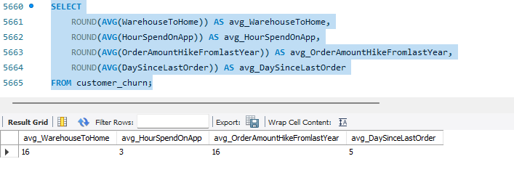

➢ Impute mode for the following columns: Tenure, CouponUsed, OrderCount.

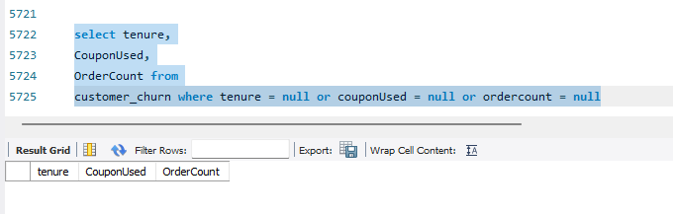

➢ Handle outliers in the 'WarehouseToHome' column by deleting rows where the
values are greater than 100.

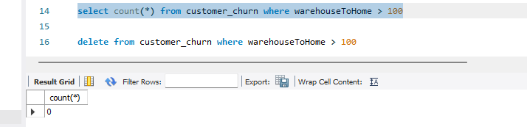

Dealing with Inconsistencies:
➢ Replace occurrences of “Phone” in the 'PreferredLoginDevice' column and
“Mobile” in the 'PreferedOrderCat' column with “Mobile Phone” to ensure
uniformity.
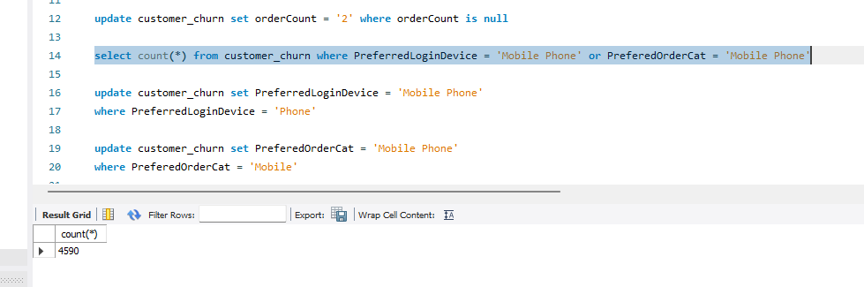

➢ Standardize payment mode values: Replace "COD" with "Cash on Delivery" and
"CC" with "Credit Card" in the PreferredPaymentMode column.
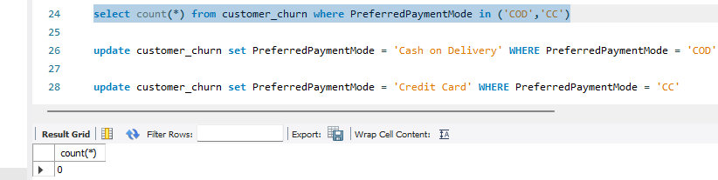

Data Transformation:
Column Renaming:
➢ Rename the column "PreferedOrderCat" to "PreferredOrderCat".
➢ Rename the column "HourSpendOnApp" to "HoursSpentOnApp".
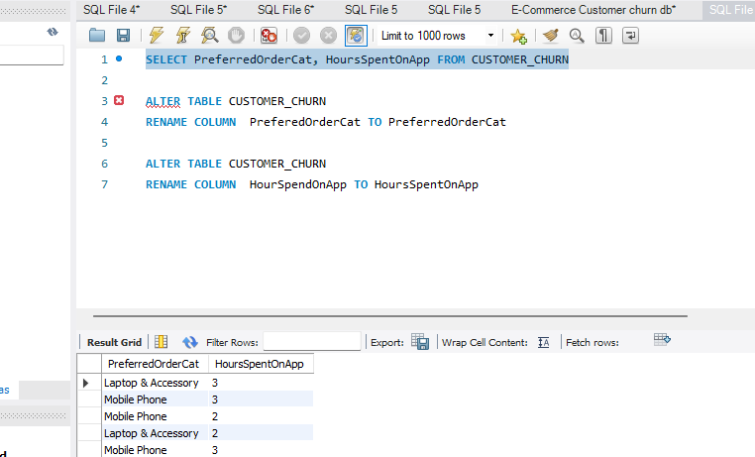
Creating New Columns:
➢ Create a new column named ‘ComplaintReceived’ with values "Yes" if the
corresponding value in the ‘Complain’ is 1, and "No" otherwise.
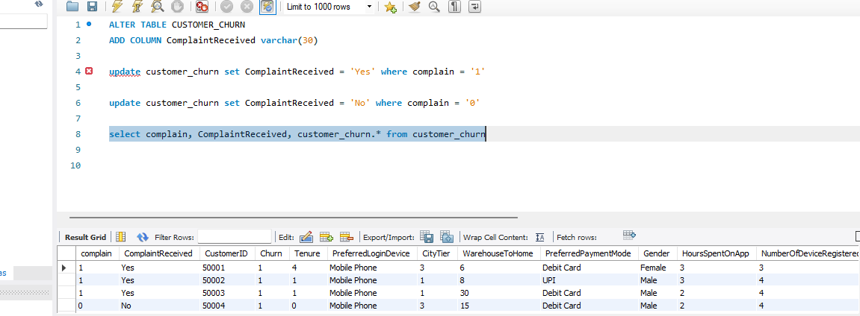
➢ Create a new column named 'ChurnStatus'. Set its value to “Churned” if the
corresponding value in the 'Churn' column is 1, else assign “Active”.
Column Dropping:
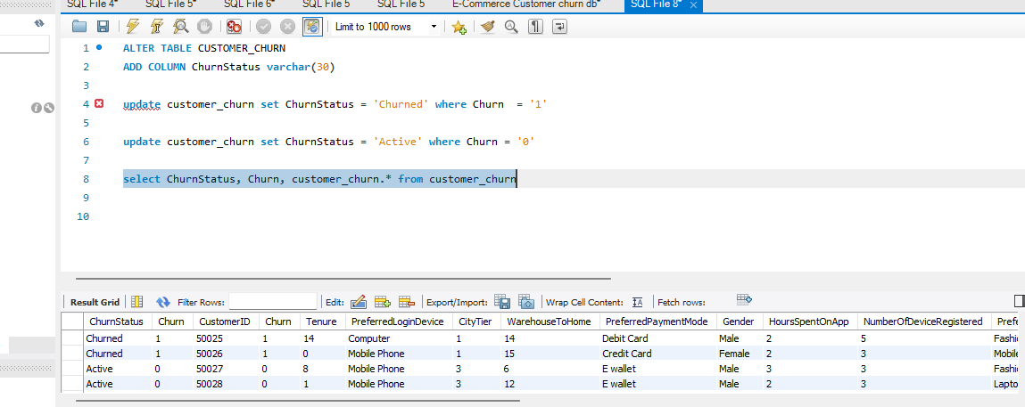
➢ Drop the columns "Churn" and "Complain" from the table.
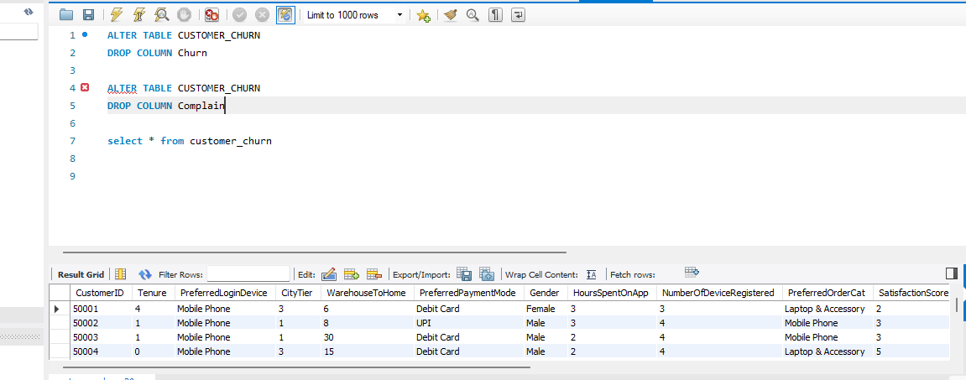

Data Exploration and Analysis:
➢ Retrieve the count of churned and active customers from the dataset.
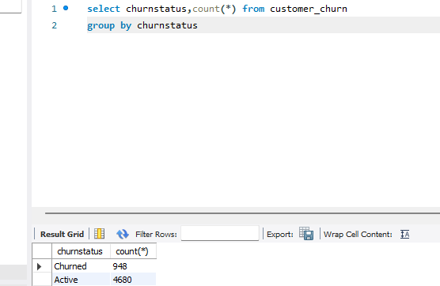
➢ Display the average tenure and total cashback amount of customers who
churned.
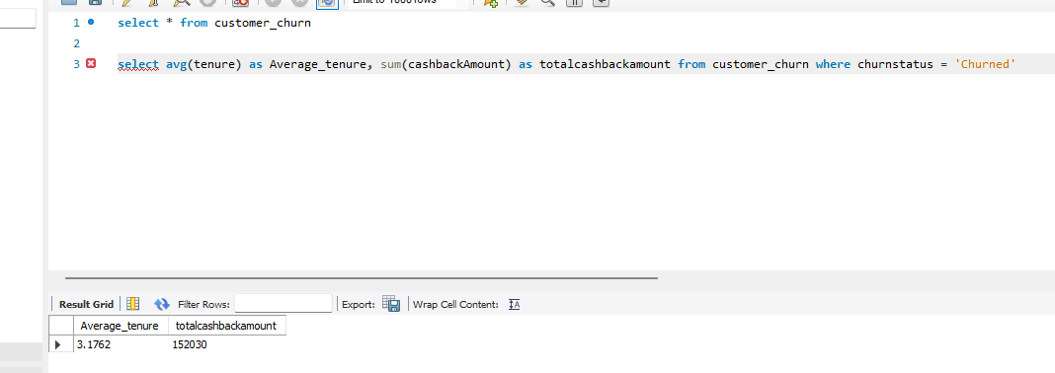
➢ Determine the percentage of churned customers who complained.
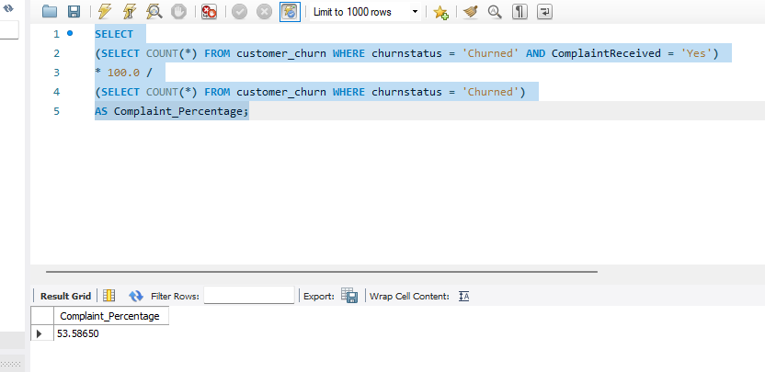
➢ Identify the city tier with the highest number of churned customers whose
preferred order category is Laptop & Accessory.
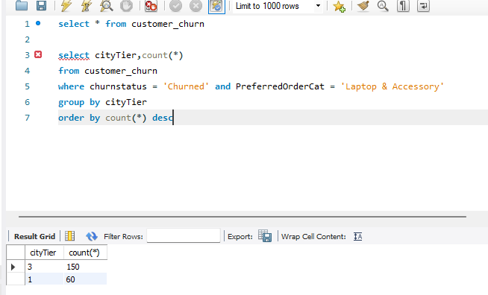

➢ Identify the most preferred payment mode among active customers.
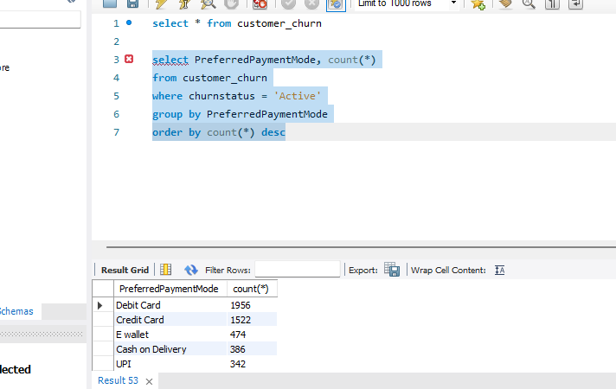
➢ Calculate the total order amount hike from last year for customers who are single
and prefer mobile phones for ordering.
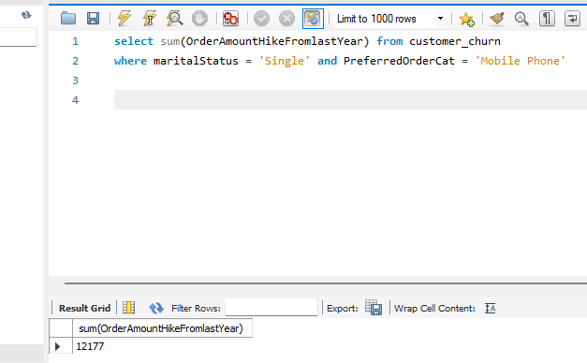
➢ Find the average number of devices registered among customers who used UPI as
their preferred payment mode.
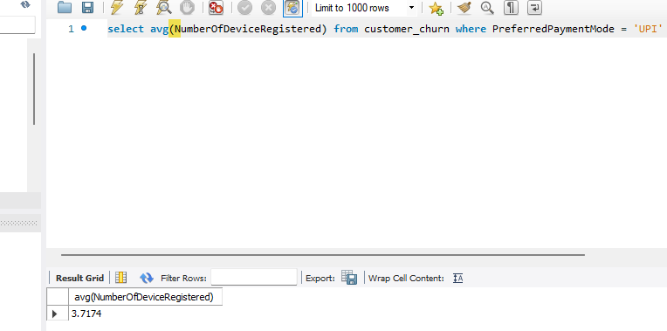
➢ Determine the city tier with the highest number of customers.
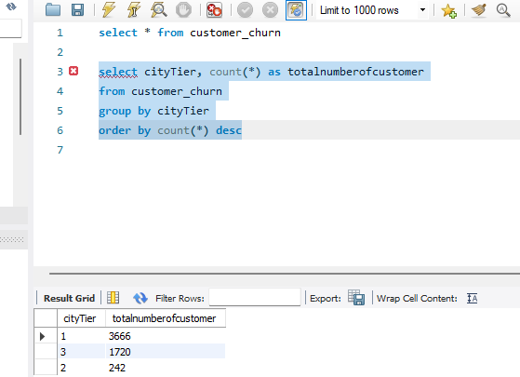
➢ Identify the gender that utilized the highest number of coupons.
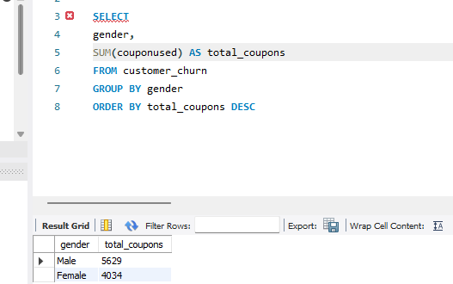
➢ List the number of customers and the maximum hours spent on the app in each
preferred order category.
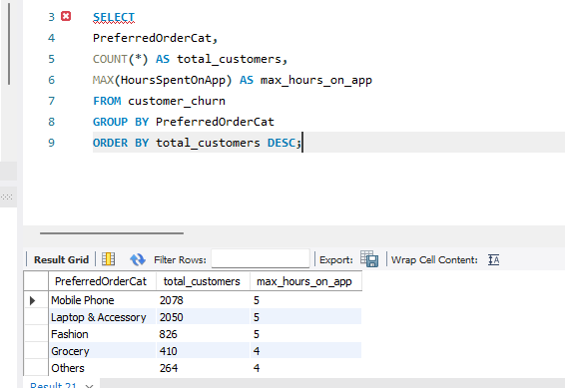
➢ Calculate the total order count for customers who prefer using credit cards and
have the maximum satisfaction score.
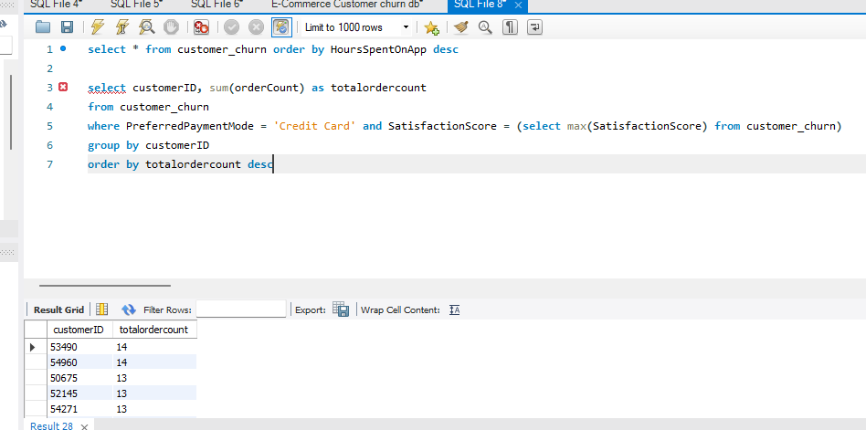
➢ What is the average satisfaction score of customers who have complained?
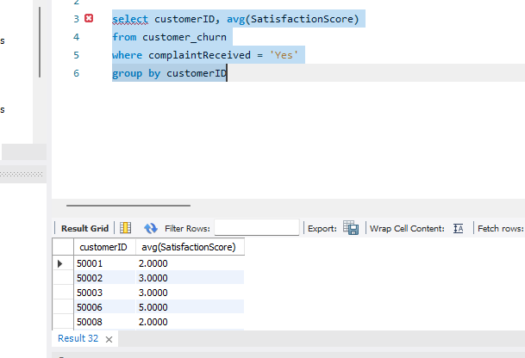
➢ List the preferred order category among customers who used more than 5
coupons.
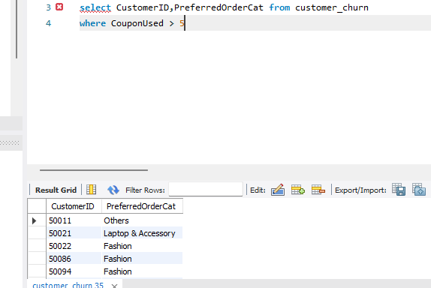
➢ List the top 3 preferred order categories with the highest average cashback
amount.

➢ Find the preferred payment modes of customers whose average tenure is 10
months and have placed more than 500 orders.
➢ Categorize customers based on their distance from the warehouse to home such
as 'Very Close Distance' for distances <=5km, 'Close Distance' for <=10km,
'Moderate Distance' for <=15km, and 'Far Distance' for >15km. Then, display the
churn status breakdown for each distance category.
➢ List the customer’s order details who are married, live in City Tier-1, and their
order counts are more than the average number of orders placed by all
customers.

➢ a) Create a ‘customer_returns’ table in the ‘ecomm’ database and insert the
following data:

ReturnID CustomerID ReturnDate RefundAmount
1001 50022 2023-01-01 2130
1002 50316 2023-01-23 2000
1003 51099 2023-02-14 2290
1004 52321 2023-03-08 2510
1005 52928 2023-03-20 3000
1006 53749 2023-04-17 1740
1007 54206 2023-04-21 3250
1008 54838 2023-04-30 1990

b) Display the return details along with the customer details of those who have
churned and have made complaints.

